FAÇADE GRANT PROGRAM
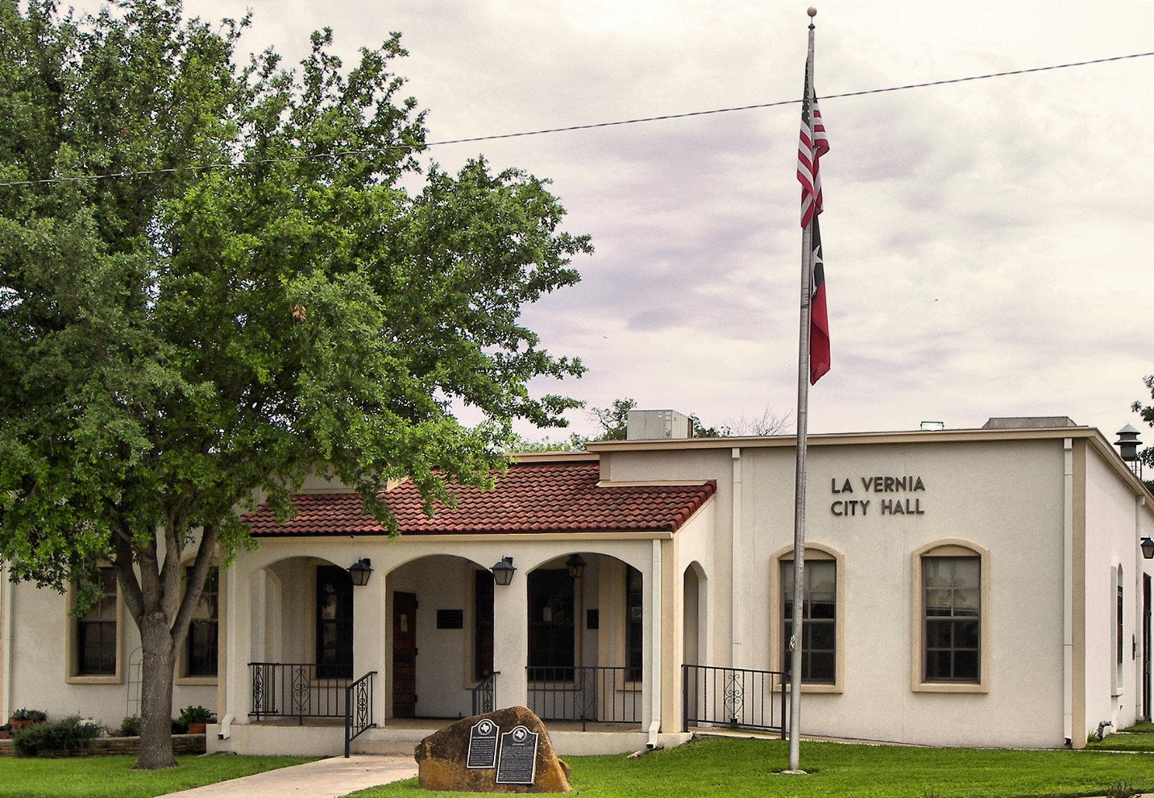
APPLICATION AND INSTRUCTIONS

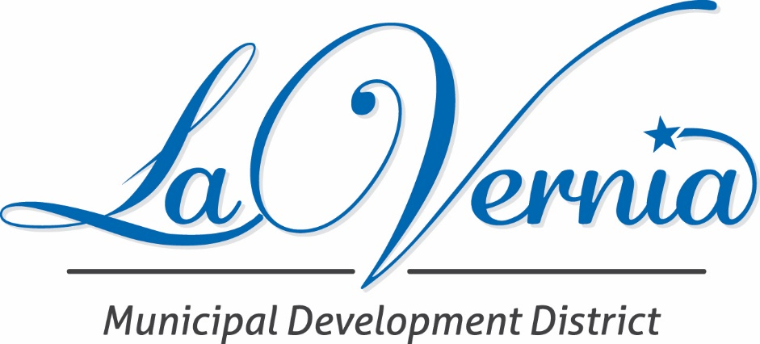

FAÇADE IMPROVEMENT PROGRAM
La Vernia Municipal Development District Façade Grant Improvement Guidelines
The LVMDD will consider, on a case-by-case basis, and may award by its sole discretion a grant to the owner of a commercial or industrial building within the city limits of La Vernia for façade improvements.
- Buildings designated as historical by the State of Texas or located in the Central Business will be given preference. Restoration of storefronts to their historic status will be given preference.
- We are looking for applicants who showcase their intent to increase curb appeal, thus, the improvements should be primarily focused on those that would be seen from the “curb.”
- Applicants are encouraged to add masonry, rock, stucco, or other materials with regard to exterior construction and architectural standards when appropriate.
- The building owner will submit drawings to the LVMDD. The drawings will illustrate the planned façade improvements. The drawings will be accompanied by cost estimates, color choices, and an estimated timeline for completion. The LVMDD Executive Director along with the building owner will present the request to the LVMDD Board.
- To receive a grant, the applicant must not begin work on the façade improvements until the grant is approved by the LVMDD.
- The applicant must submit photos of the completed work and a receipt of all costs incurred before the reimbursement money will be distributed.
- The applicant is expected to complete the work that was presented in the Façade grant application and agreed upon in the board meeting in order to be reimbursed.
- If signage on the building is part of the façade improvement, the cost of signage must not exceed the owner’s share of the project’s total cost.
- If landscape improvements to the front/ sides of the building are part of the façade improvement and add to the general curb appeal, they will be considered, the applicant will be expected to upkeep the landscape.

- LVMDD will approve up to a maximum of $5,000 or 50% of the actual cost of the façade improvements, whichever is less. The LVMDD Executive Director shall certify proof of expenditures, the date the project is completed, and must recommend payment before funds are disbursed by the LVMDD.
- The owner of the property must be current on all property taxes.
- All contractors working on the façade improvements are required to be registered with the City of La Vernia.
- The following items are not eligible for reimbursement: roofing, parking lot paving, fencing, or interior building improvements.
- The LVMDD may not expend more than $25,000 in this grant program from October 1st to September 30th each year.
- There shall be no repeat applicants approved for funding per each 3-year window.

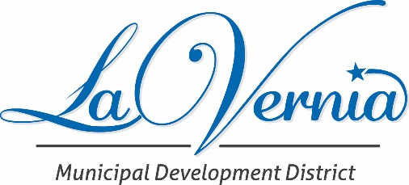

Name:
Phone and email address
Address and Legal Description of Property (applicant may attach maps and other illustrations)
Describe the proposed alterations, changes, repair, and maintenance work in detail. Attach paint chips for changes that include repainting the structure. The LVMDD Board may require the submission of product samples and other technical information pertinent to the design. Review decisions.

Desired Start Date Completion Date
Total Projected Cost Projected Grant
Attach a copy of an accurate graphic representation of the proposed work. This may include detailed plans, elevations, photos, and amateur or architectural drawings.

Signature of Applicant Date

For LVMDD Office Use
Application Received
Meeting Date and presentation made:
Decision of the LVMDD Board of Directors:
Date applicant is notified:
LA VERNIA MUNICIPAL DEVELOPMENT DISTRICT STANDARD AGREEMENT FOR THE FAÇADE GRANT PROGRAM

THE STATE OF TEXAS §
§ KNOW ALL MEN BY THESE PRESENTS:
COUNTY OF WILSON §

THIS IS AN AGREEMENT, made and entered into by and between the La Vernia Municipal Development District, a Municipal Development District created by and through the laws of the State of Texas, hereinafter called "LVMDD", acting by and through its duly authorized representative, and , hereinafter called "GRANTEE," acting by and through its duly authorized representative.

W I T N E S S E T H:
WHEREAS, the La Vernia Municipal Development District has created and approved a process whereby buildings located within the City of La Vernia Central Business District may apply for a façade improvement grant from the LVMDD; and

II.
WHEREAS, upon an affirmative vote of the majority of LVMDD Board, on _______________, the LVMDD determined that GRANTEE qualified for a grant in the amount of ______________ (the “funds”) for façade improvements as provided for in its application and that said funds shall be distributed to GRANTEE under the following terms and conditions:
(a) For and in consideration of the distribution to GRANTEE by the LVMDD, the funds distributed shall be used by GRANTEE for the sole purpose of _______________________ (the “Project”). All funds shall be for the following expenditures:

(b) The remittance of the funds by LVMDD will be upon written request by GRANTEE. The written request will indicate what the funds will be used for and the date the project is to commence. LVMDD shall remit the funds within fifteen (15) days of receipt of the written request by GRANTEE.
(c) The Project shall be completed by ________. Should GRANTEE fail to complete the project by the specified completion date then, upon written demand by the LVMDD, GRANTEE shall, within 30 days of receiving the written demand, repay all funds received and shall remit 10% interest per annum on all funds received from the time GRANTEE received the funds from the LVMDD.
(d) Upon completion of the Project, GRANTEE shall submit a final financial accounting (the “report”) to the LVMDD showing a line item accounting of all expenditures made during the Project which shall be accompanied by the check register of all related expenditures. Invoices, receipts, or other proofs of expenditures shall be presented with the report.
(e) Any funds GRANTEE receives that remain after the completion of the Project are to be returned to the LVMDD within 30 days of completion of the Project. If it is determined that GRANTEE has used the funds for any purpose other than those identified in paragraph II(a) of this contract or has breached this contract in any fashion, GRANTEE shall repay all improper expenditures and shall remit 10% interest per annum on all improper expenditures from the time GRANTEE received the funds from the LVMDD.
(f) All funds received from LVMDD shall be accounted for in a separate bank account and shall not be co-mingled with other cash funds.
(g) GRANTEE shall at all times comply with the ordinances of the City of La Vernia and the laws of the State of Texas.

III.
In the performance of this contract, GRANTEE shall not discriminate against any employee or applicant for employment or with any customer with respect to his hire, tenure, terms, conditions, or privileges because of his race, color, religion, national origin, sex, disability, or ancestry. A proven breach of this covenant may be regarded as a material breach of the contract causing its termination.

IV.
It is understood and agreed that in the event any provision of this contract is inconsistent with the requirements of law, the requirements of law will control and the parties shall revert to their respective positions which would otherwise be enjoyed or occupied by the respective parties for the terms of this contract.

V.
The foregoing instrument in writing between the parties herein, constitutes the entire agreement between the parties, relative to the funds made the basis hereof, and any other written or oral agreement with the LVMDD being expressly waived by GRANTEE.
IN WITNESS WHEREOF, the parties hereto execute this agreement in duplicate originals as of the date set forth above on this ____ day of ________________ 20_____.
LA VERNIA MUNICIPAL DEVELOPMENT DISTRICT, TEXAS
BY: __________________________________

[Grantee]
BY: __________________________________

